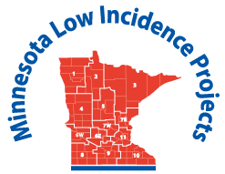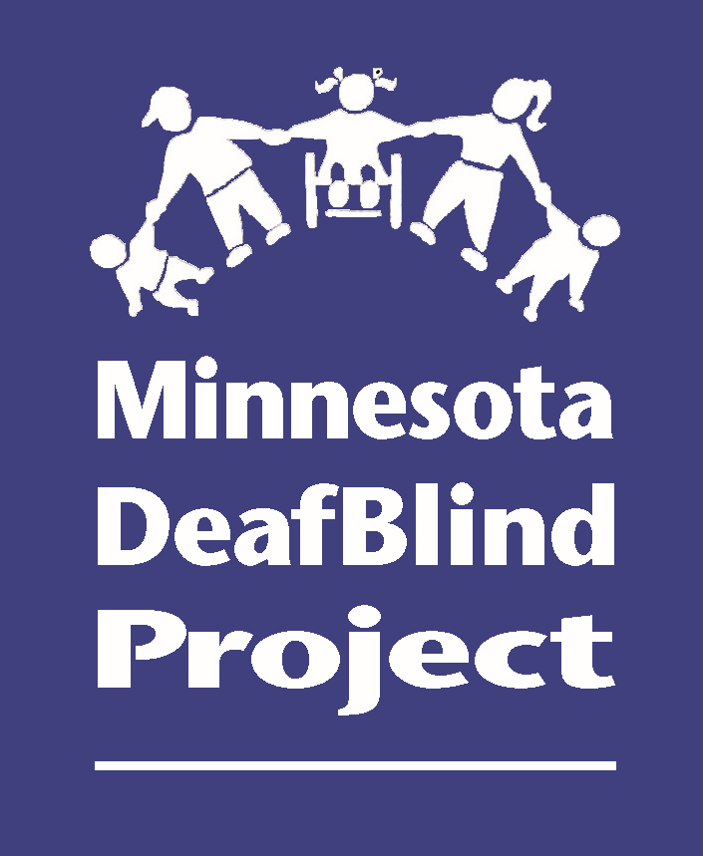
Minnesota Teachers of Students Who Are Deafblind
Community of Practice
February 24-25, 2020
Metro ECSU - Training Room - 1st Floor
Anderson Center - 2 Pine Tree Drive, Arden Hills, MN 55112
Informal Functional Hearing Evaluation and
Determining What Deafblind Students May Be Accessing

Day 1 Presenters:
Adam Graves has 15 years of experience working with students who are Deafblind. For the past five years, he has provided technical assistance as a DeafBlind Education Specialist with the Texas DeafBlind Project. He co-created the Informal Functional Hearing Evaluation (Montgomery & Graves 2017) and the webinar series Hearing Issues for Students with DeafBlindness (Graves & Montgomery 2016). Mr. Graves recently published the article Braille Literacy Statistics Research Study: History and Polities of the “Braille Reader Statistics”: A Summary of AFB Leadership Conference Session on Education in the Journal of Visual Impairment & Blindness (Graves, 2018). He is also a doctoral student in special education at Texas Tech University. In addition, Mr. Graves serves as a member of the board of directors of the CEC’s Division for Visual Impairment and DeafBlindness (DVIDB) and the CEC committee on maltreatment.
Amy Baxter has been working with students who are DeafBlind for over 8 years. She holds a master’s degree in deaf education and hearing science from the University of Texas Health Science Center, San Antonio. Ms. Baxter has worked in a variety of public schools throughout Texas including the Texas School for the Deaf and the Texas School for the Blind and Visually Impaired. She has served students who are Deaf and DeafBlind in a variety of positions including as a preschool and elementary school teacher and early childhood intervention specialist. Currently, Ms. Baxter provides services for students from the ages of 6 to 22 as the DeafBlind consultant for comprehensive programs at TSBVI. In addition to her work in the educational field, Ms. Baxter also serves children and adults in the Austin, Texas area by working as an intervener in the home and community settings.

Monday, February 24, 2020 Day 1

9:00-9:30 a.m. Registration, Networking (coffee and tea provided)
9:30-9:45 a.m.. Welcome, introductions, updates
9:45-10:15 a.m. Background information about the IFHE
10:15-10:45 a.m. Why and When would you use the IFHE?
10:45-11:00 a.m. Break
11:00-12:00 p.m. 4 Parts of the IFHE - Parent and Team Interviews
12:00-1:00 p.m. Lunch provided on site, Networking
1:00-1:45 p.m. 4 Parts of the IFHE, including O&M - The Observation Checklist
1:45-2:30 p.m. 4 Parts of the IFHE - The Report Summary
2:30-2:45 p.m. Break
2:45-3:30 p.m. Questions, Comments and Concerns

Day 2 Presenters:
Ann Mayes has over 30 years of experience teaching deaf, hard of hearing and deafblind students in a variety of settings including general education, resource rooms, self-contained classes and day programs. She has a passion for interpreting evaluation results and data so that team members are better able to understand the impact of combined hearing and vision loss (deafblindness) and will be sharing examples of how to write statements for present levels of academic achievement and functional performance (PLAFFPs) infused throughout the IEP so that it is a comprehensive view of the student. She also has worked with both proficient and emergent communicators who are deafblind and those in between. Currently, Ann is the new statewide education specialist/consultant and is very involved with the National Center on Deaf-Blindness initiatives for proficient communicators.
Community of Practice Representatives who have been using the Toolkit for several years will also be sharing tools they’ve found particularly helpful and how they implement their use.

Tuesday, February 25, 2020 Day 2

8:15-8:30 a.m. Arrival, Networking (coffee and tea provided)
8:30 - 9:15 a.m. Unpacking the Toolkit: Stories from the Field of Experienced CoP
representatives
9:15-10:00 a.m. Writing Deafblind Impact Statements: So we have the data, what does it mean?
10:00-10:15 a.m. Break
10:15-11:15 a.m. What’s Working and Not Working for Academic and Proficient Communicators?
11:15-11:30 Wrap Up and Evaluation
To register for the Deafblind Community of Practice: http://www.metroecsu.org/registration/Events Search: DeafBlind Community of Practice Meeting. The registration fee for Monday, February 24 only is $20.00. This fee includes: coffee/tea, lunch, snack and handouts. Lunch will ONLY be served on Monday, February 24, 2020. There is no registration fee for Tuesday, February 25. You do need to register for each day that you plan to attend.
If you need a hotel room, the following hotels are approximately 5 minutes from the meeting location. Reservation and payment needs to be arranged by you or with your district.

Hilton Garden Inn  1050 Gramsie Rd  Shoreview, MN 55126  651-415-1956 | Country Inn & Suites  2740 Snelling Ave N  Roseville, MN 55113  651-628-3500 | Best Western Plus  1000 Gramsie Rd  Shoreview, MN 55126  651-482-0402

Academy for Certification of Vision Rehabilitation & Educational Professionals (ACVREP) continuing education hours will be provided.

This initiative is made possible with a grant from the MN Department of Education using federal funding CFDA 84.027A Special Education – Grants to States. This initiative does not necessarily represent the policy of the federal Department of Education or the state Department of Education and you should not assume endorsement by the federal or state government.

